VOICE STUDIES AT CARLETON COLLEGE

Whether you are interested in classical songs & arias or musical theatre, Carleton offers voice students the opportunity to pursue their musical interests at all levels and in a variety of styles. We create an open and safe space for students to explore and we encourage our students to pursue their love and passion for music however they see fit. We encourage conversation with students and other faculty and all are open to exploring their voice.

Features of the Voice Studies Program at Carleton include:
*Weekly Voice Performance Classes, where students can hone their performing skills.
*Opportunities for regular coaching sessions with a professional pianist.
*Themed Showcase Recitals near the end of each term.
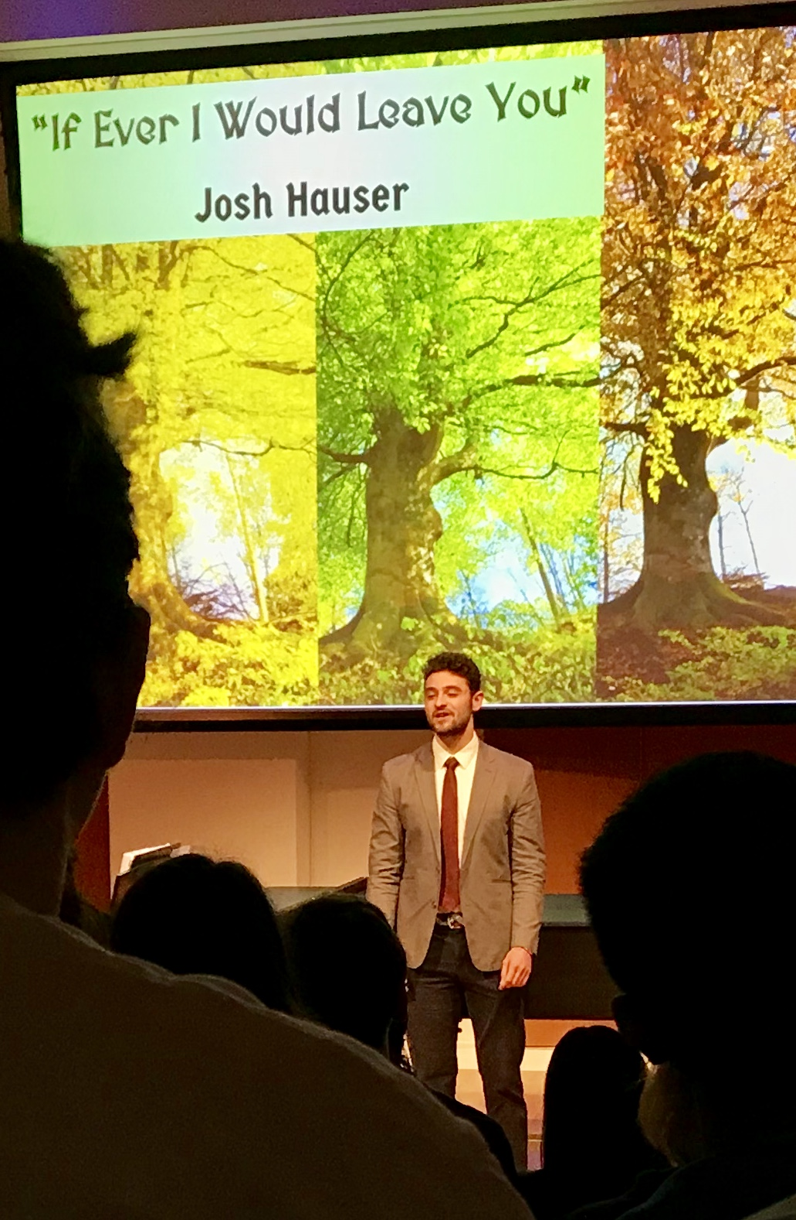

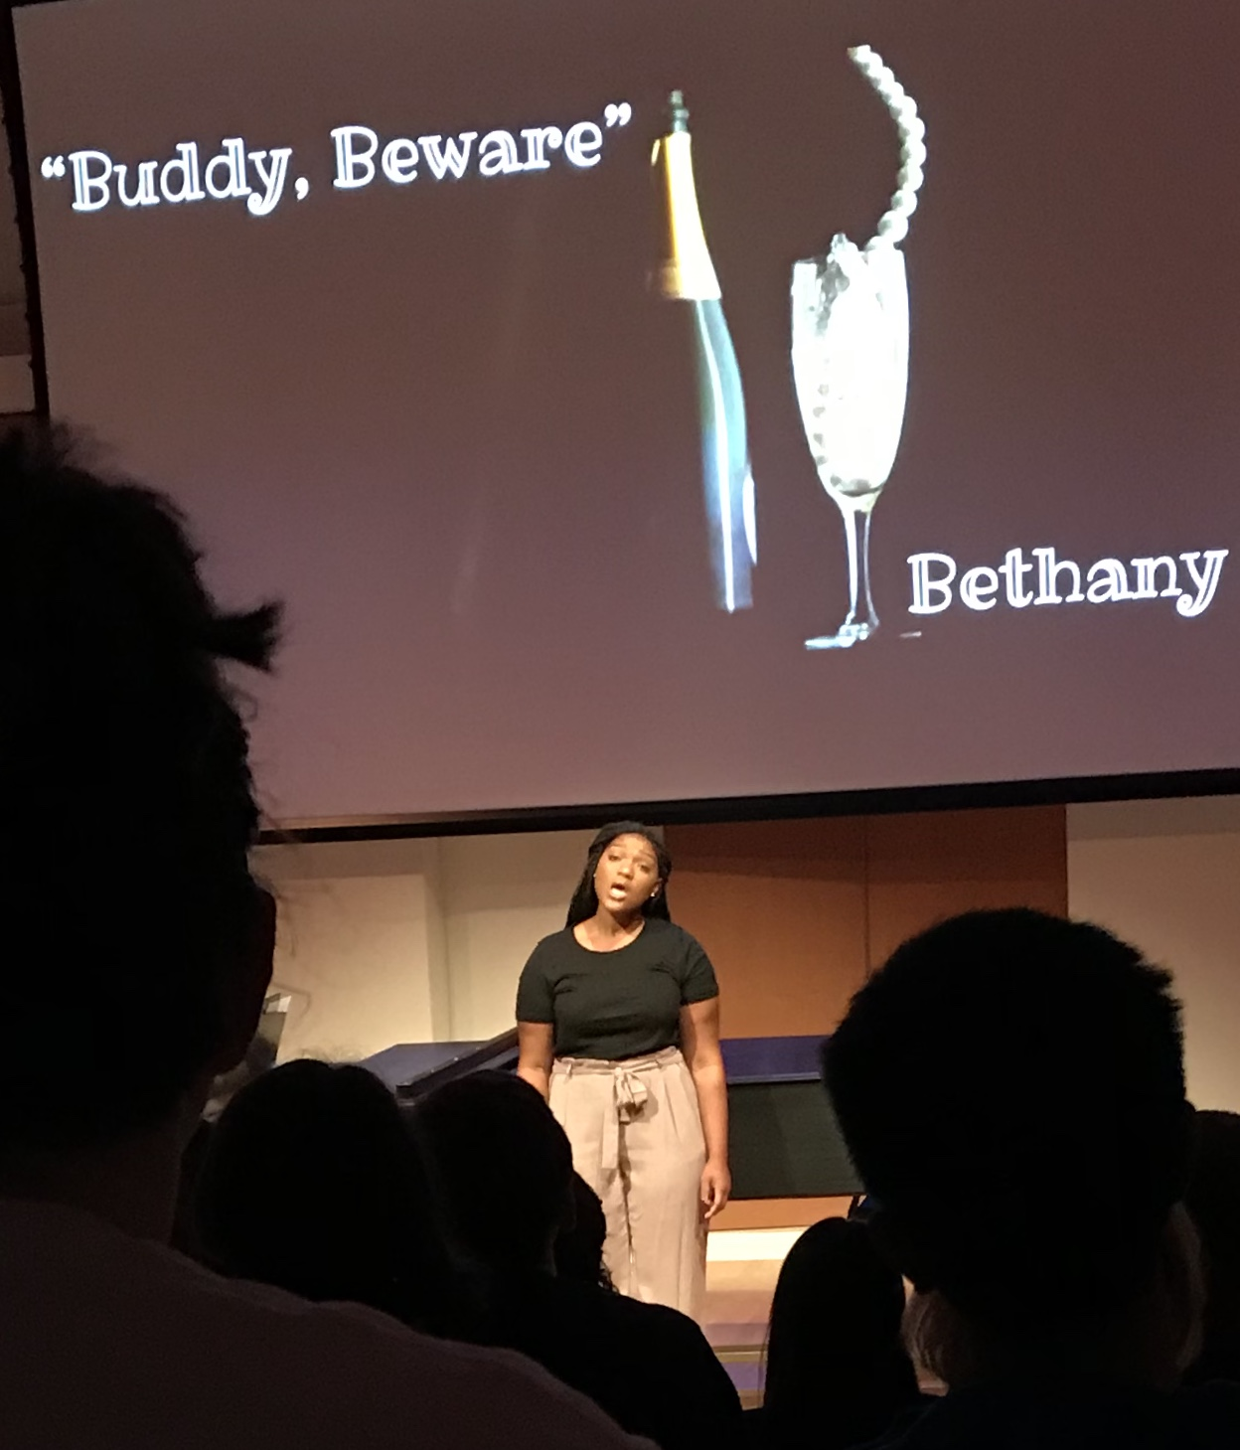

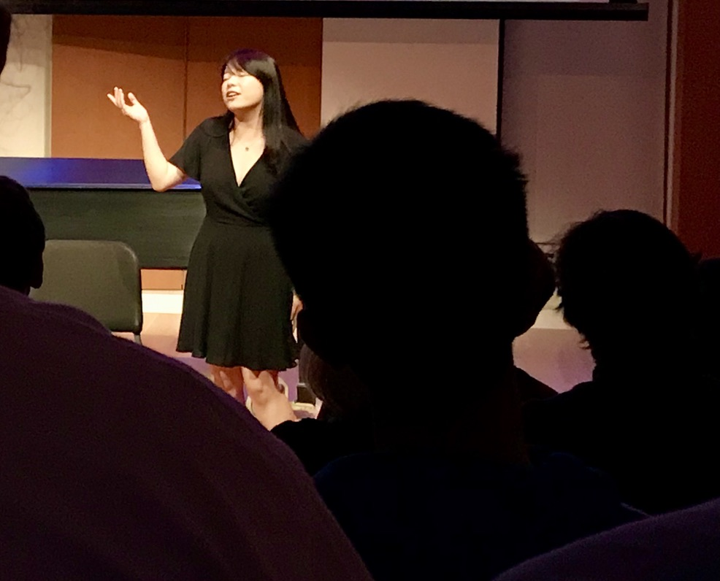

Voice Studies Program Faculty and Staff

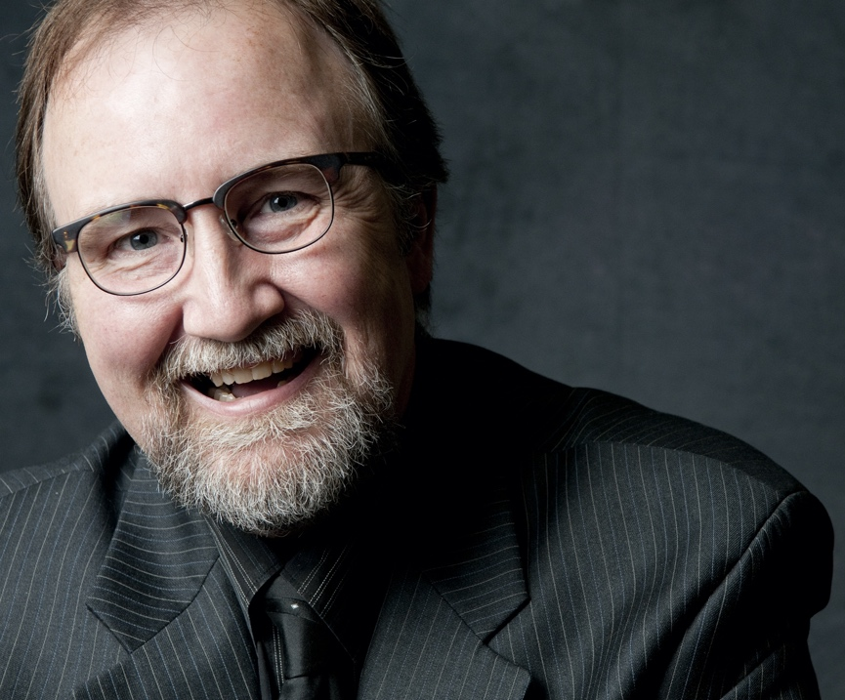
Rick Penning, (Senior Lecturer in Voice/Voice Studies Program Coordinator) has earned the Doctor of Musical Arts degree from the School of Music at the University of Minnesota, the Master of Music degree from the College-Conservatory of Music at the University of Cincinnati and the Bachelor of Arts degree from Luther College.

A past 1st Place winner of the Metropolitan Opera District competition, he has performed over 35 operatic roles with opera companies across the United States. Most recently, he was featured in the role of Bill Watson in the world premiere of the acclaimed Minnesota Opera production of THE SHINING, an operatic retelling of the Stephen King novel.

He has appeared as tenor soloist with the Saint Paul Chamber Orchestra, the Minnesota Orchestra, Minnesota Chorale, Rochester Symphony (Minnesota), Arapahoe Symphony (Colorado) and the Bismarck/Mandan Symphony Orchestra (North Dakota).

Rick Penning is fortunate to have had many wonderful mentors in his life, including current voice teachers David L. Jones (New York City). At the beginning of his operatic career, he was privileged to have enjoyed a long relationship with H. Wesley Balk, considered by many to have revolutionized the way singer-actors are trained.

He maintains a busy voice studio at Carleton College (since 1983!) as well as a studio at Augsburg University and his home studio. His students have won awards and have gone on to studies at the great conservatories and major apprenticeship programs, and they have performed with opera and musical theatre companies and on concert stages around the world.

Teaching Philosophy
Dr. Penning believes in a collaborative approach with the student in developing the voice as a healthy, efficient musical instrument capable of the full gamut of human emotional expression. He finds particular joy in exploring vocal repertoire from a myriad of styles and genres with his students.

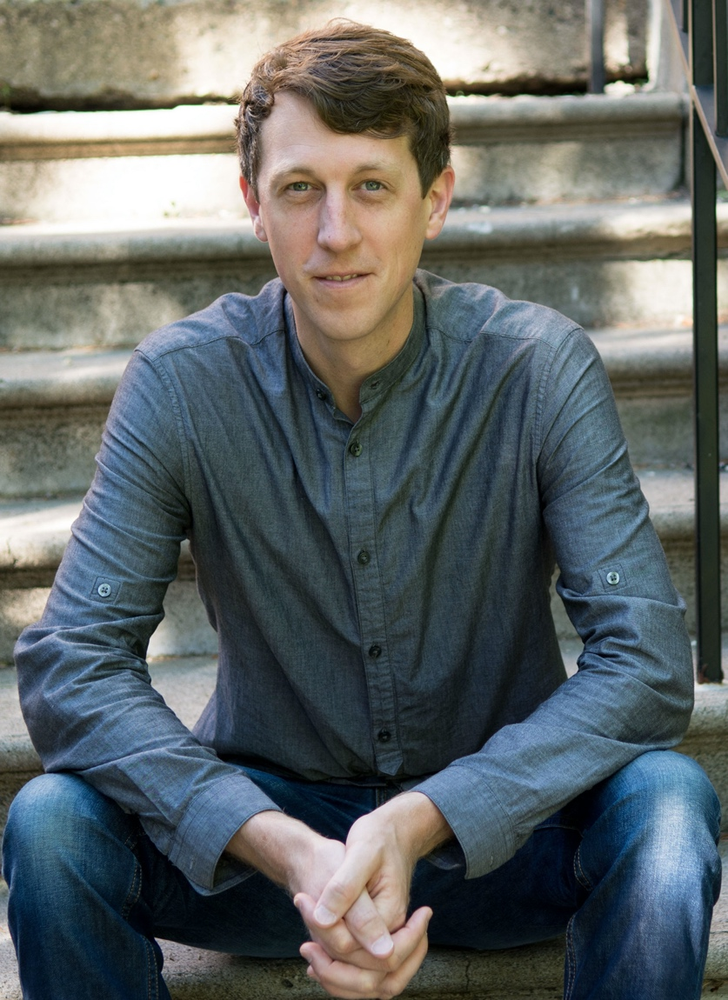
Matthew Olson is Director of Choirs at Carleton where he also teaches voice lessons. His vocal background as both a teacher and performer are diverse including interest in classical, musical theatre, a cappella, bluegrass, folk, and indie-rock music. As a professional chorister, he has performed with the Minnesota Orchestra, St. Paul Chamber Orchestra, Detroit Symphony, and Orchestra of St. Luke’s (NYC). He is Assistant Conductor and Bass section leader of The Singers – MN Choral Artists. He is also an experienced singer-songwriter having headlined Minnesota Public Radio and The Current 89.3’s popular Works for Words concert series live at the Fitzgerald Theatre. He has shared the stage with artists ranging from Sims of the hip hop collective Doomtree, to Rogue Valley and Caroline Smith, to GRAMMY Award-winning songwriter Carrie Newcomer. He is also well-versed in a cappella, having been director of Michigan State University’s Spartan Dischords and the University of Minnesota’s Vocal U. He studied choral and orchestral conducting as well as voice at St. Olaf College, The Oregon Bach Festival, Michigan State University, and The University of Minnesota.

Teaching Philosophy
Teaching voice lessons is such a privilege because the human voice is the only instrument we are all born with inextricably linked to our mind, body, and spirit. It is no wonder, then, that singing can be deeply joyful yet nerve-racking, and vulnerable yet profoundly authentic all at the same time. While our background in music may vary as we enter college, we all hold the potential to improve the health and beauty with which we sing. As a voice teacher, I strive to embrace the natural voice you have been given as well as your musical interests. From this launching point, I work to help you improve your technique as a singer, and broaden your exposure to diverse musical styles.

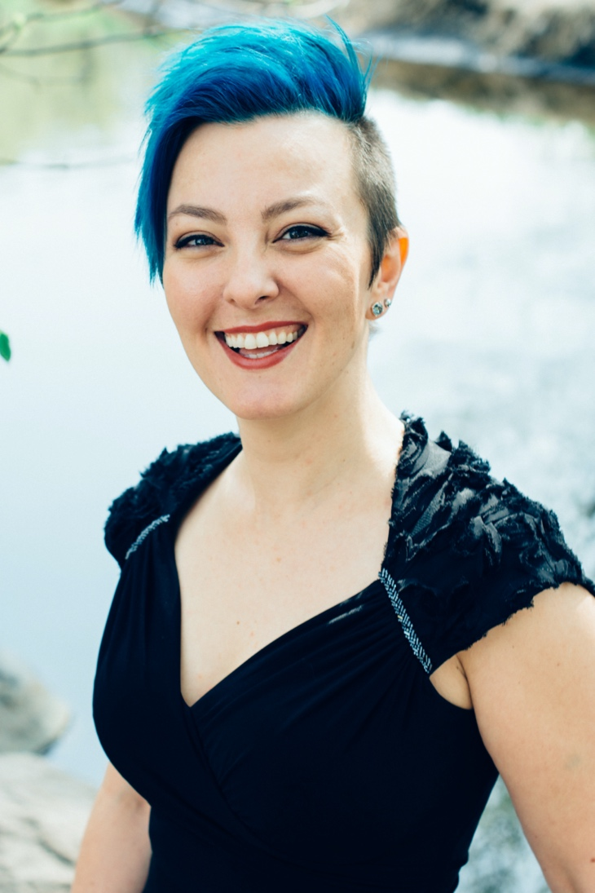
KrisAnne Weiss, mezzo-soprano, enjoys an eclectic performing career of music-theater and concert work, and is an accomplished recitalist, chamber musician, and narrator. She has performed with opera and concert organizations throughout the midwest, including Skylark Opera, AOT Opera Theatre, Lyric Opera of the North, Minnesota Opera, the Metropolitan Symphony Orchestra, Duluth-Superior Symphony Orchestra, Zeitgeist, and Nautilus Music-Theater, among many others. An advocate of contemporary composers and art song, Dr. Weiss has premiered and workshopped countless new compositions, among them John Tartaglia’s orchestral work Dark Night, Glad Day, Edie Hill’s dramatic concert work Amy Lowell: A Rare Pattern, and the lead role in Chris Gable’s opera The Ladysmith Story. She is the host and facilitator of AOT Opera Theatre’s Voice Labs, a free artistic development resource for local singers at any point in their careers.

Dr. Weiss completed her undergraduate degrees (B.M. Voice, B.A. English) at Lawrence University, and her Master of Music and Doctor of Musical Arts degrees at the University of Minnesota, where she received the University Fellowship, the Graduate Research Partnership Program Grant, and the Schuessler Graduate Prize in Voice. She has taught on the voice faculties of the University of Minnesota, Lawrence University, Luther College, Mount Olivet School of Music, Lutheran Summer Music Festival and Academy, and St. Olaf College. She has also been a private voice teacher for over 15 years, working with students of all ages, abilities, and musical aspirations.

Philosophy
I believe that voice study is, among other things, a path toward personal growth. As a teacher, I am excited about training future musical professionals, but I am equally if not more interested in encouraging the development of well-rounded, intellectually curious, and artistically empathetic human beings, regardless of their professional aspirations. My teaching style is holistic and collaborative, and prioritizes technical, intellectual, and artistic development. While my own training is largely in Western classical vocal technique, I am passionate about and inspired by many different musical styles, and the music we work on in lessons will be informed by both my expertise and the student’s interests and goals.

My favorite teaching tools, besides sound voice science and physiological reality, are empathy, imagination, and hilarity. I try to take the work seriously without taking myself too seriously, and I encourage students to do the same.

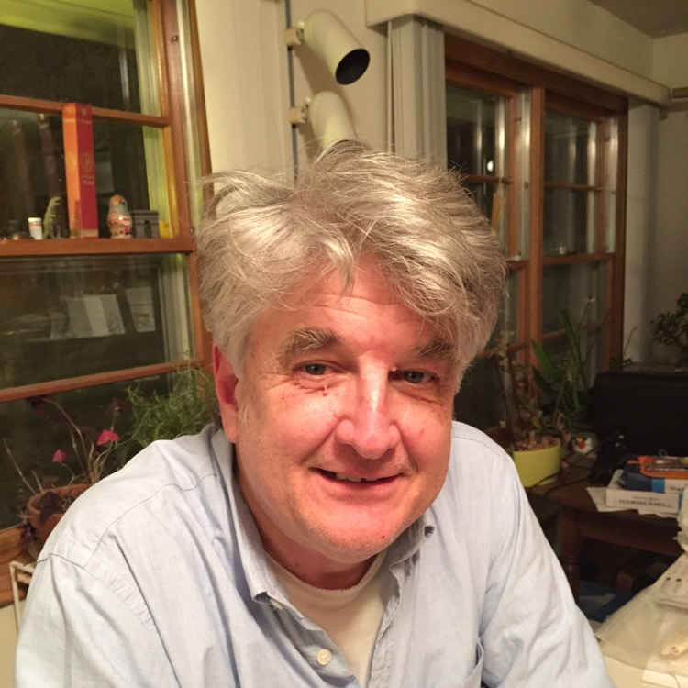
Thomas Bartsch
(Voice Studies Program Collaborative Pianist)
In addition to serving as the collaborative pianist for the voice department at Carleton, Thomas Bartsch is also the staff accompanist at St. Olaf College in Northfield, MN and at Augsburg University in Minneapolis. Tom pursues a busy career as a free-lance accompanist/pianist. He is the organist at St. Michael's Lutheran Church in Roseville and the Organist/Choir Director at Temple of Aaron Synagogue in St. Paul.

For more information, or if you have any questions or concerns, please feel free to contact Rick Penning, Coordinator for the Voice Studies Program at < rpenning@carleton.edu >
Please refer to and read carefully the information on the Music Department website for details regarding registration policies and protocols:
https://apps.carleton.edu/curricular/musc/applied/

